Latest Coronavirus Information

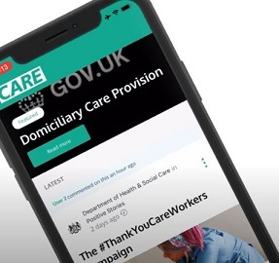

Do you work in social care in England? You can now receive the latest coronavirus information, guidance, wellbeing support and discounts direct to your smartphone or inbox.

Or sign up to view the content online

